GIT HOL 1
Verify PATH and Launch Notepad++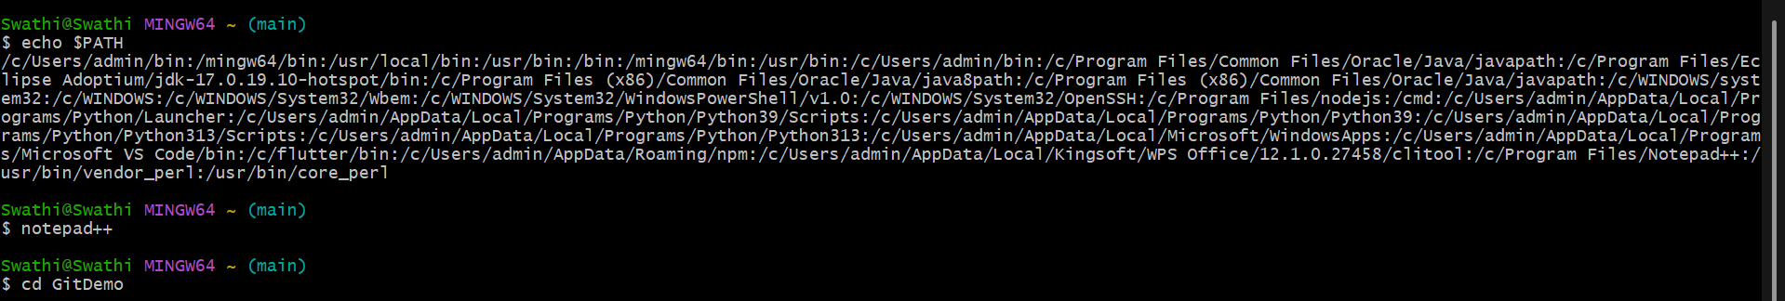
SET Notepad++ as Default Editor & Check File Status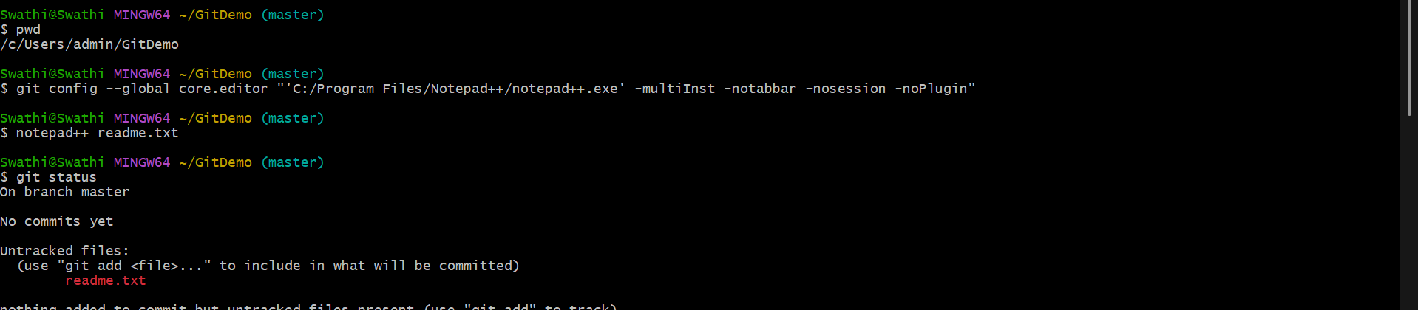
Stage and Commit the File
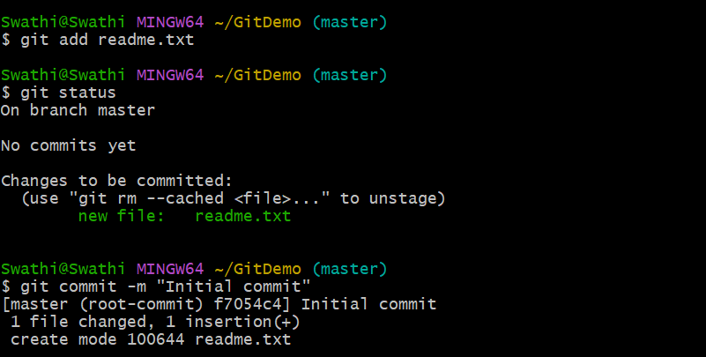

Add remote and Initiate

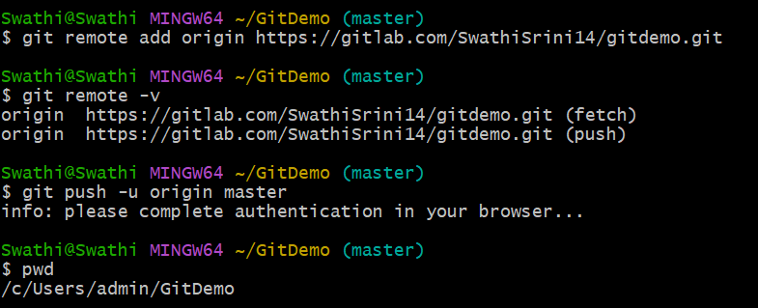
Push Completed Successfully!
